**Chocolate Dipped Marshmallows , Chocolate Covered Pretzels, Puppy Chow, Sugar Cookies,**

**Mouse Kisses, Chocolate Hearts, Red Velvet Truffles, Oreo Balls, Meringue Kisses**

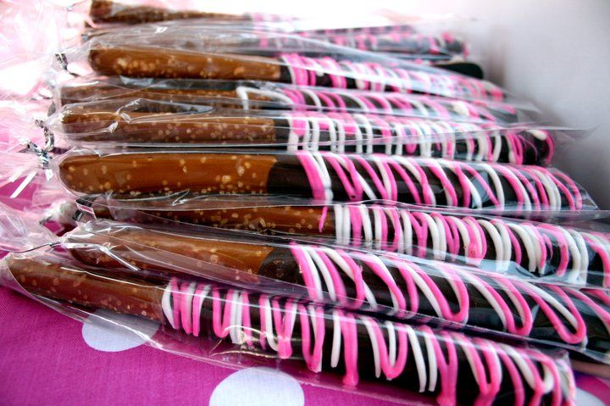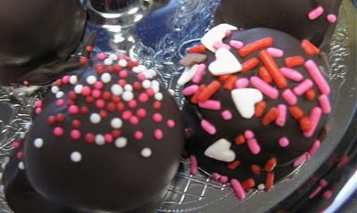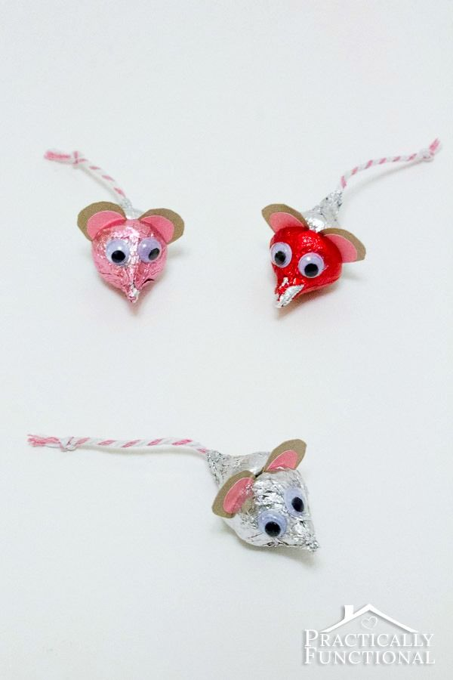

**ALIVE’S Valentines for Vetting Boxes**

***(Decorated and Ready to give your Valentine!)***

**$10 per Box—Delivered on Friday, February 13th**

**Each Featuring a Picture of a Animal “Rescued By Love”**

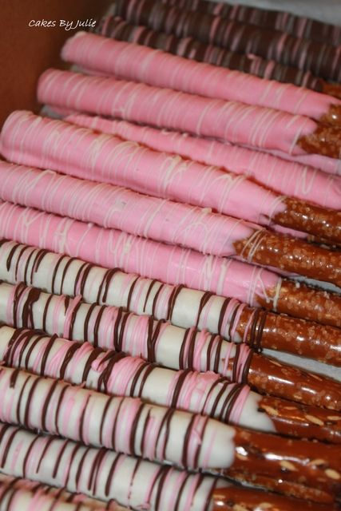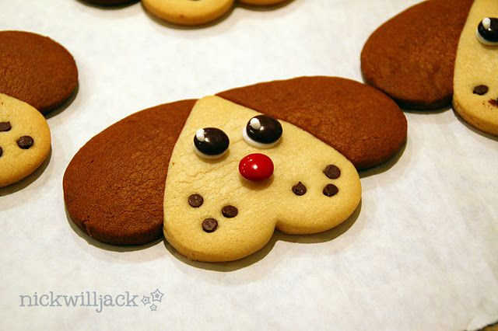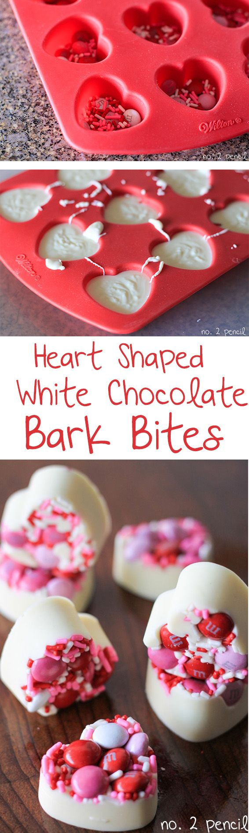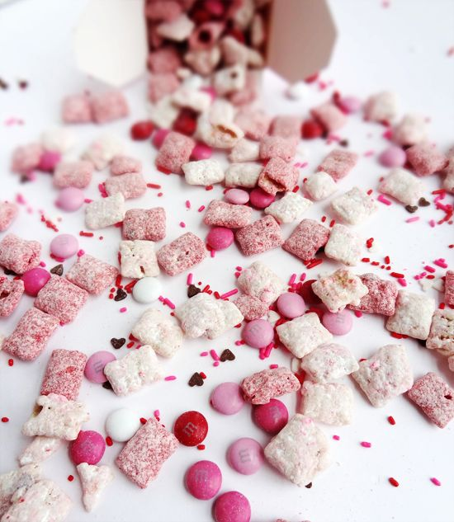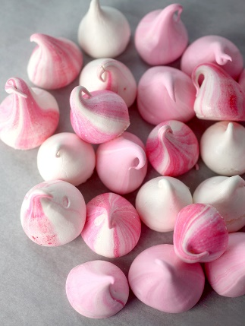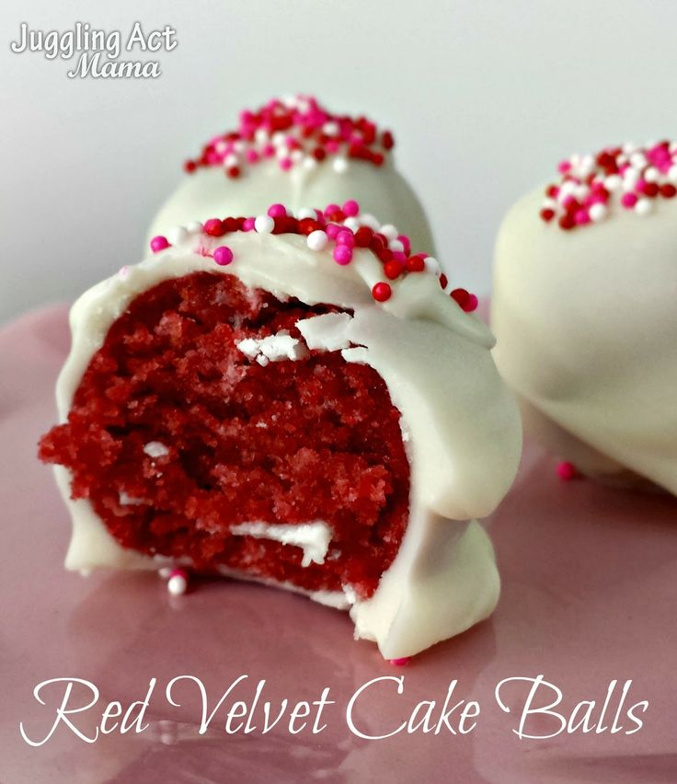

**Valentines’ For Vetting ____________________**

**(Rescued By Love)**  (Business Name)

**Delivered on Friday, February 13th**

**$10.00 Donation per Box**

*Proceeds will provide funds for vetting extended to injured, abused, and sick animals*

*in our community and impounded at Mercer County Animal Shelter.*

**Name Name**

**_______________________ ______________________**

**_______________________ ______________________**

**_______________________ ______________________**

**_______________________ ______________________**

**_______________________ ______________________**

**_______________________ ______________________**

**_______________________ ______________________**

**_______________________ ______________________**

***Each Box Decorated for***

***Valentine’s Day and featuring a Picture of an animal rescued by love!! A variety of sweets***

***including…***

**Chocolate Dipped Marshmallows,**

**Chocolate Covered Pretzels, Puppy Chow, Puppy Love Sugar Cookies,**

**Mouse Kisses, Chocolate Hearts, Red Velvet Truffles, Oreo Balls,**

**Meringue Kisses**

