Apples for Animals Fundraiser - ____________
(Business Name)
Delivered on
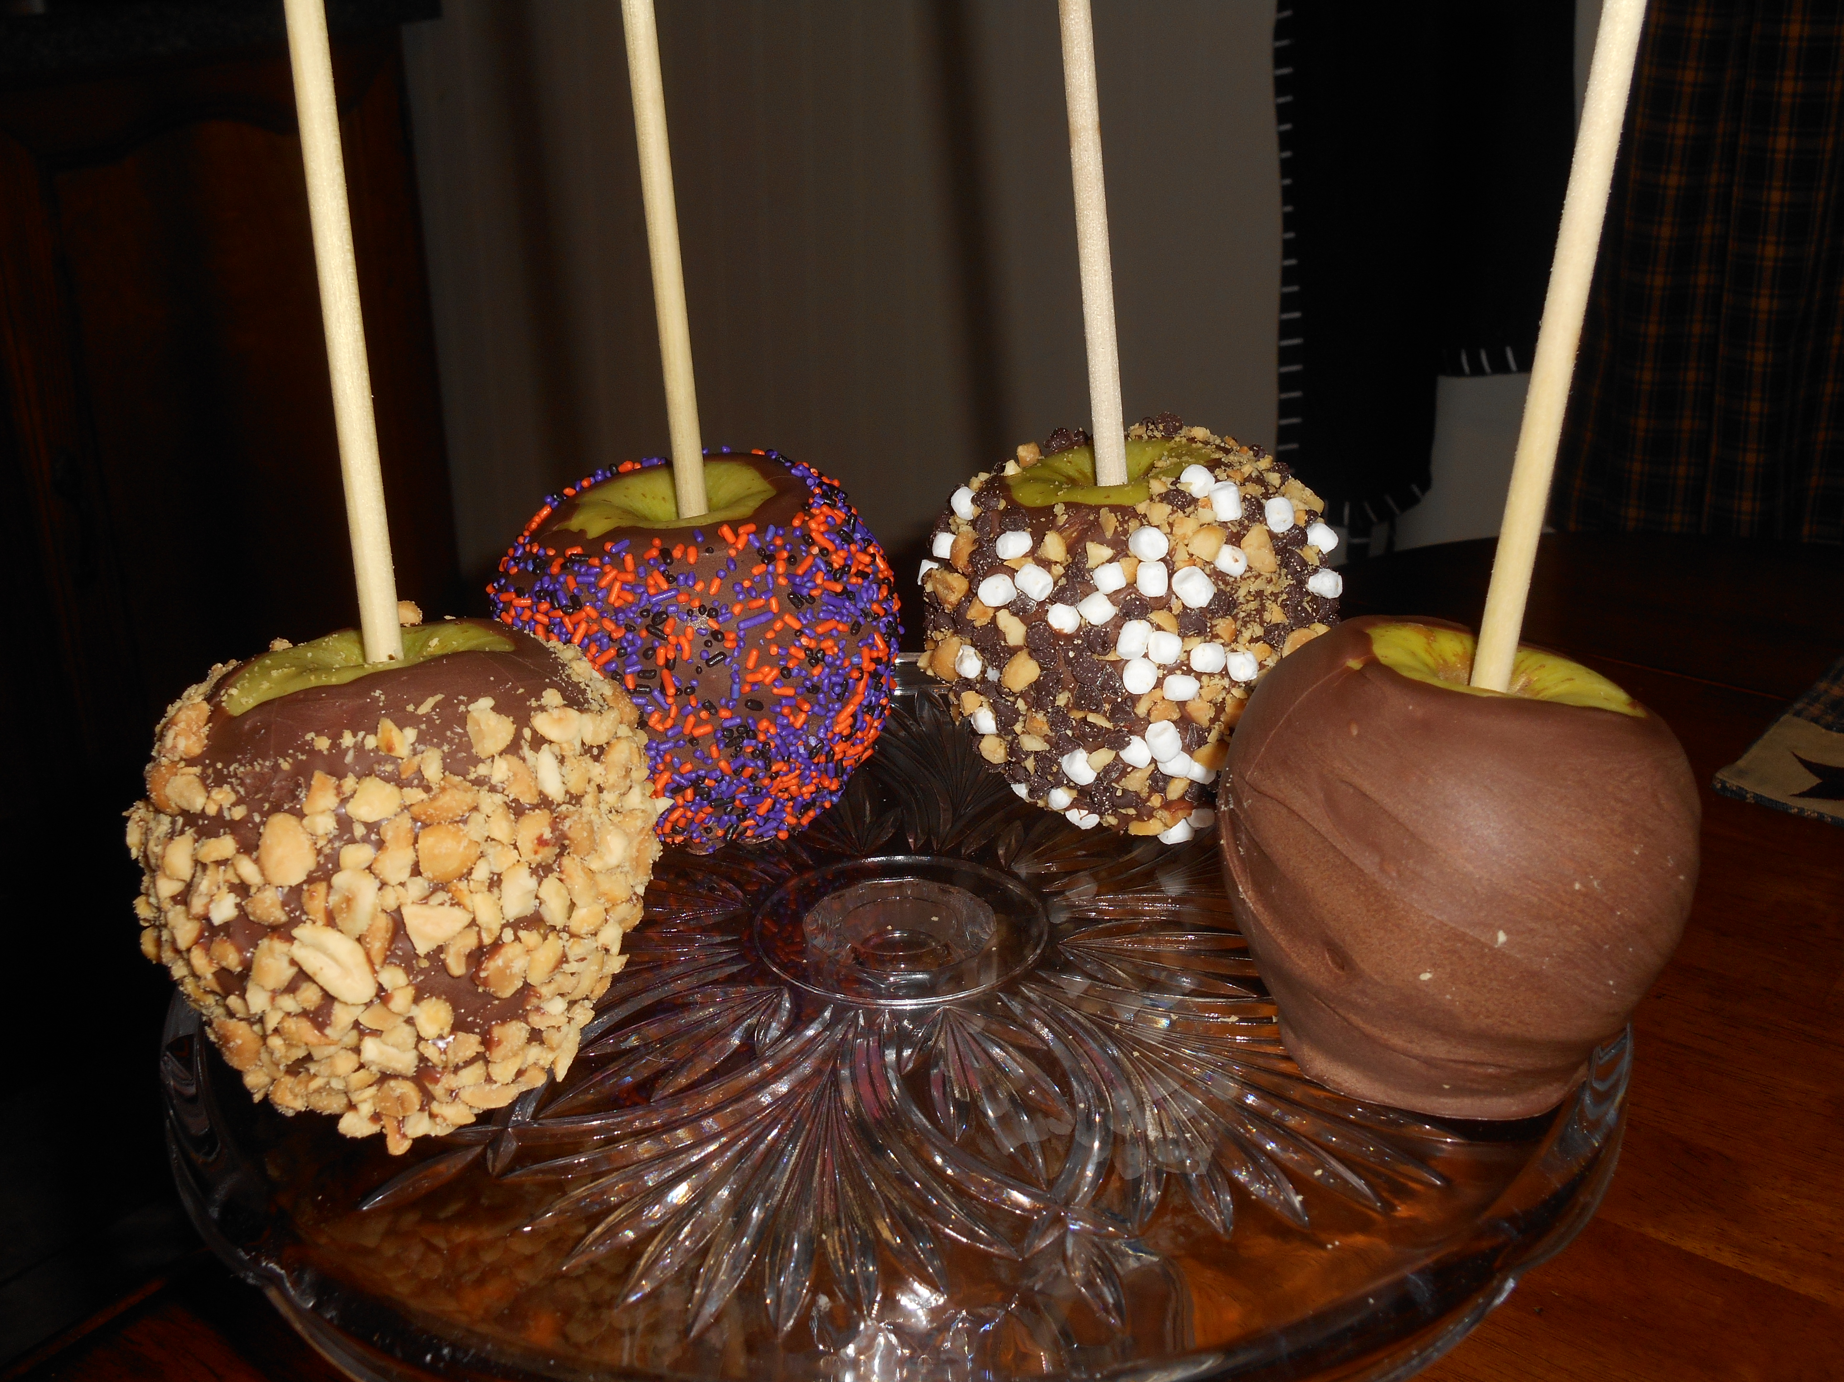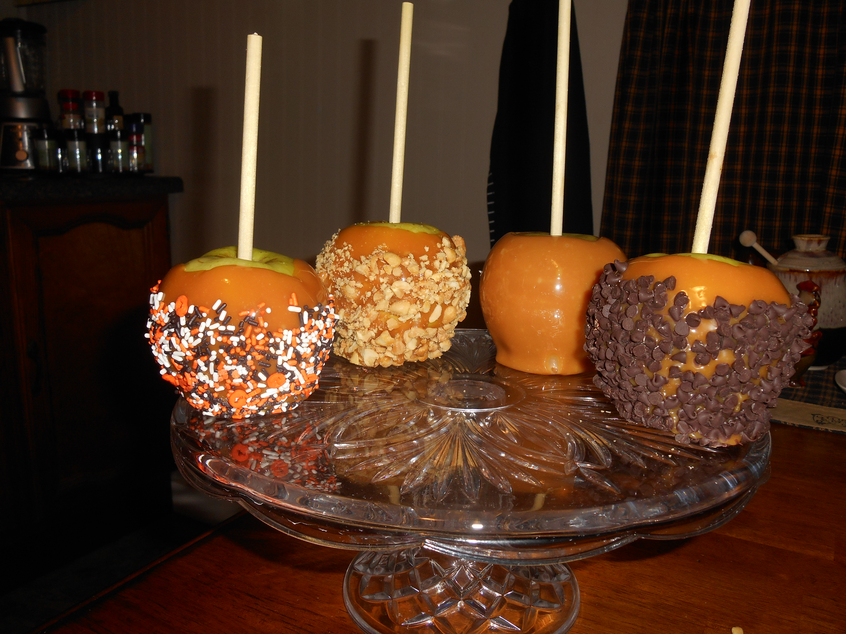
Monday, October 27th
(All Apples will be individually wrapped with a Halloween theme.)
Choices:
Caramel $4, Caramel w/nuts $5, Caramel w/choc chips $5, Caramel w/sprinkles $5
Chocolate Covered $4, Chocolate w/ nuts $5, Chocolate w/ sprinkles $5
Rocky Road (chocolate, nuts, mini marshmallows, and chocolate chips) $5
Funds raised will provide vetting, transport, and fostering for area animals in need.
Name Type of Apple Ordering
____________________ ___________________
____________________ ___________________
____________________ ___________________
____________________ ___________________
____________________ ___________________
____________________ ___________________
____________________ ___________________
____________________ ___________________
Name Type of Apple Ordering
____________________ ___________________
____________________ ___________________
____________________ ___________________
____________________ ___________________
____________________ ___________________
____________________ ___________________
____________________ ___________________
____________________ ___________________
____________________ ___________________
____________________ ___________________
____________________ ___________________
____________________ ___________________
____________________ ___________________
____________________ ___________________
____________________ ___________________


